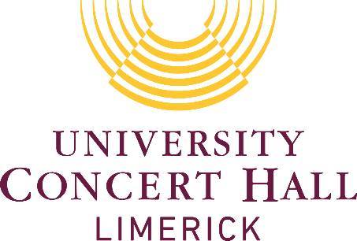

**TERMS & CONDITIONS**

Ticket is offered subject to terms and conditions and without prejudice to all the terms and conditions exhibited; we would draw the holder’s attention to the following conditions of sale.

1. The concert may be recorded live for use in the form of sound recordings, television videotapes and other means of audio and audio-visual reproductions, not known and to be invented. The purchaser of this ticket consents to participate in the said recordings and grants all necessary consents for Performs Protection Acts.

2. Holder assumes all risk of injury and all responsibility for the property loss, destruction or theft and releases promoters, artists, sponsors, venue, ticket outlets and their employees from any liability therefore.

3. The ticket outlet is acting merely as a retailer of this ticket at the request of the promoter and accepts no liability whatsoever for any loss incurred by the purchaser of this ticket if the event does not take place in whole or in part.

4. The management reserve the right to refuse admission.

5. No refunds or exchanges will be given after the ticket has been purchased.

6. In the unlikely event of a cancellation the customer is entitled to a full refund which can be arranged by contacting the Box Office directly. Alternatively, UCH will credit the customers UCH account to the value of the tickets. This credit can be used against the purchase of tickets or a gift card at any time.

7. Please note that booking fees (which are processing and service charges) and postage fees are none refundable. In the event of a refund the customer will receive the face value of the tickets only.

8. Admission to venue is by ticket and e-ticket only.

9. The use of flash photography is strictly forbidden.

10. Latecomers will not be admitted after the performance has commenced.

11. Please advise Box Office in advance of any specific access requirements. Designated wheelchair spaces can only be booked via The Box Office